**When to use which graph**

**🡪Bar chart**



**🡪Pie chart**

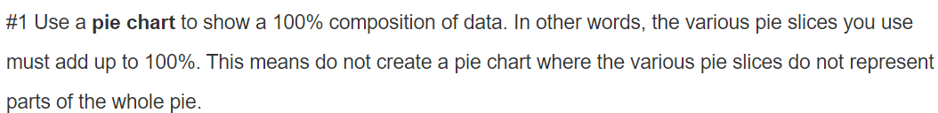

**🡪Clustered chart**



**🡪Line chart**

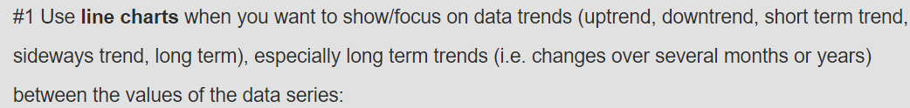

**🡪Histogram**



**🡪Actual vs Target Chart**





**🡪Scatter chart**



**🡪Stacked 100% column**



**🡪Combinational chart**

